
Touchstones
Netcards

Acceptance Netcards with Text

Believe in You HRJ
Clock HRJ
Clown HRJ
Couple HRJ

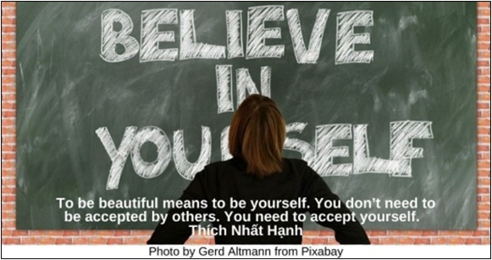

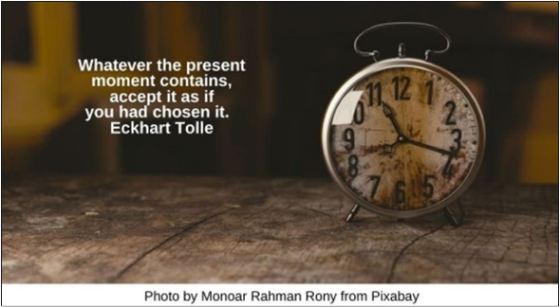

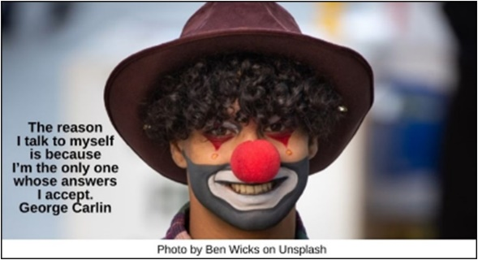



Dictionary HRJ
Different HRJ
Fear HRJ
Flaws HRJ

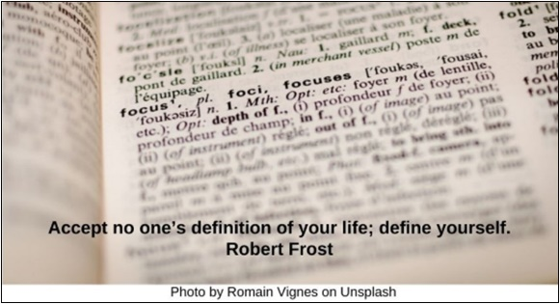

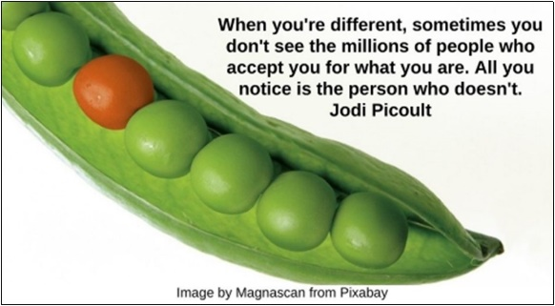

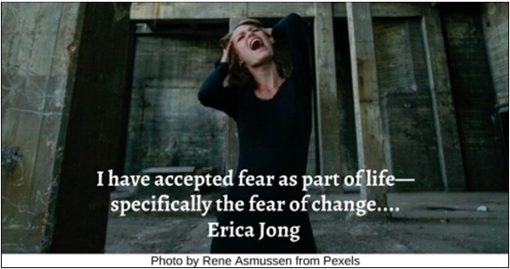

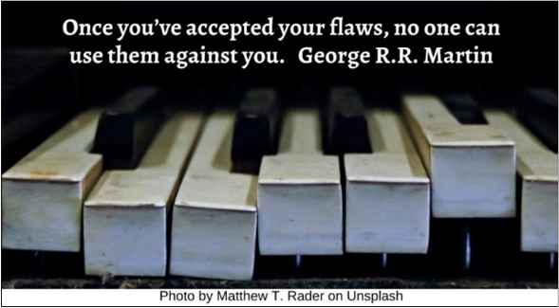

Fly HRJ
Gratitude HRJ
Infinite Hope HRJ
Looking in the Mirror HRJ

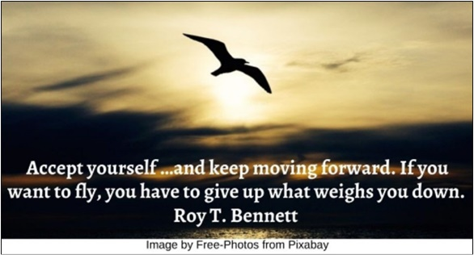

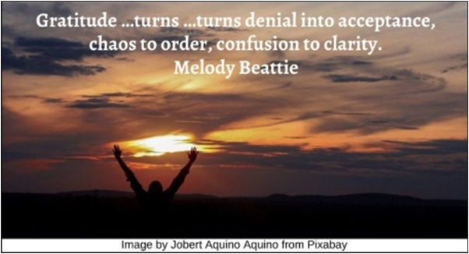

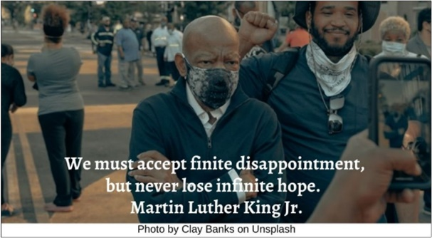

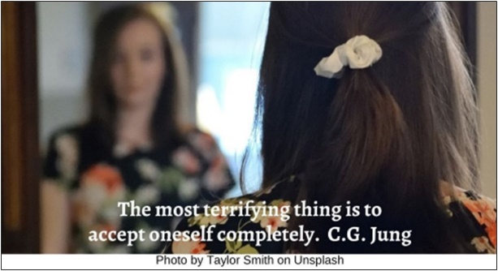

Love HRJ
Mirror HRJ
Missing Piece HRJ
Old room HRJ

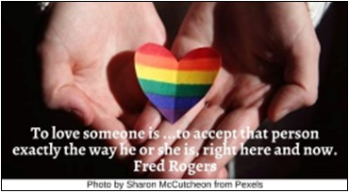

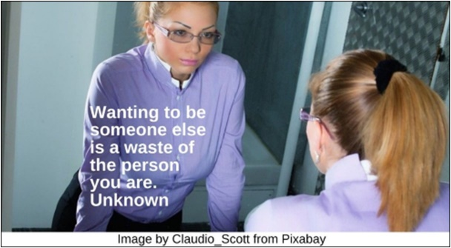

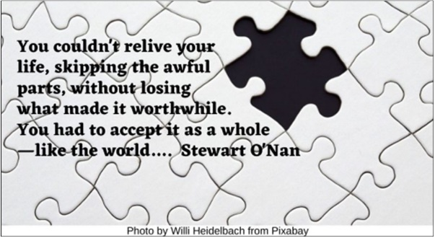

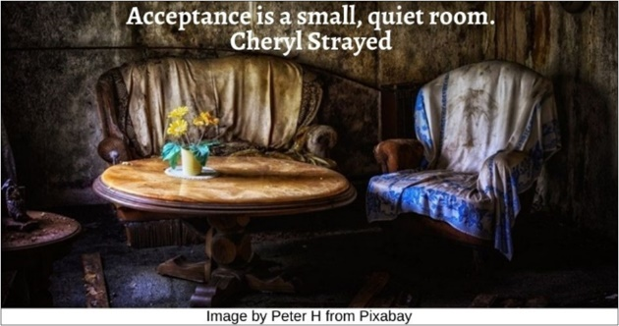

Old Woman HRJ
Peace HRJ
Quiet HRJ
Rain HRJ





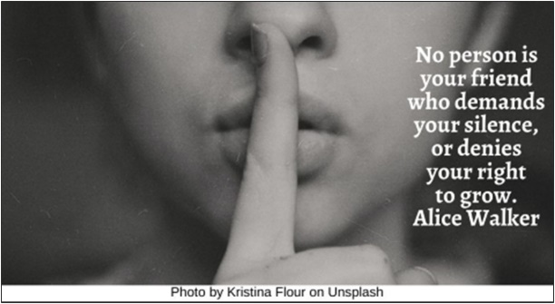

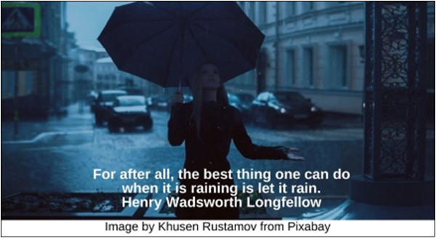

Reflection HRJ
River HRJ
Scanning HRJ
Snow Flower HRJ

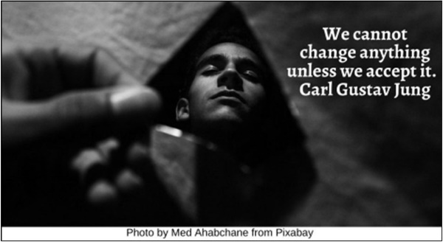

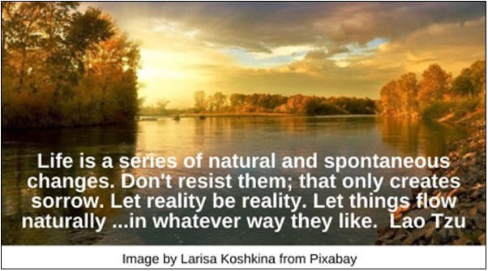

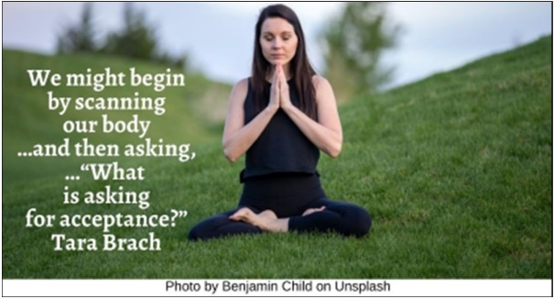

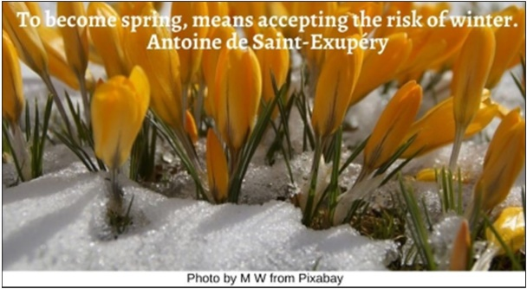

Sunset HRJ
Surprise HRJ
Thinking HRJ
Vulnerable HRJ





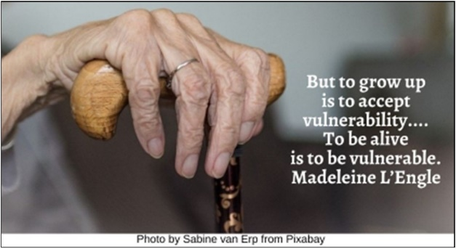

Wondering HRJ
World HRJ
Writing HRJ

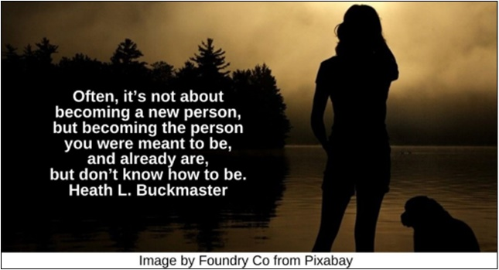

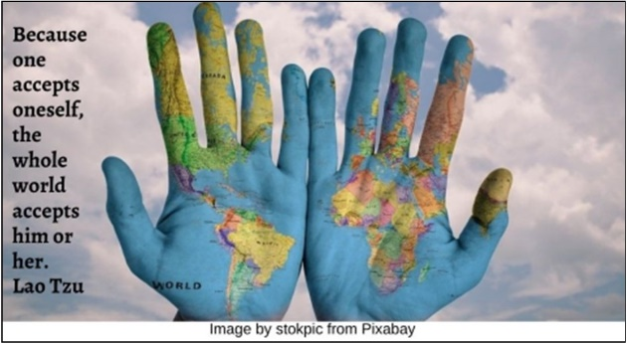



Text of Quotes

Believe in you HRJ
To be beautiful means to be yourself. You don’t need to be accepted by others. You need to accept yourself. Thích Nhất Hạnh

Clock HRJ
Whatever the present moment contains, accept it as if you had chosen it. Eckhart Tolle

Clown HRJ
The reason I talk to myself is because I’m the only one whose answers I accept George Carlin

Couple HRJ
To be fully seen by somebody, then, and be loved anyhow—this is a human offering that can border on miraculous. Elizabeth Gilbert

Dictionary HRJ
Accept no one’s definition of your life; define yourself. Robert Frost

Different HRJ
When you’re different, sometimes you don’t see the millions of people who accept you for what you are. All you notice is the person who doesn’t. Jodi Picoult

Fear HRJ
I have accepted fear as part of life—specifically the fear of change... Erica Jong

Flaws HRJ
Once you’ve accepted your flaws, no one can use them against you. George R.R. Martin

Fly HRJ
Accept yourself …and keep moving forward. If you want to fly, you have to give up what weighs you down. Roy T. Bennett

Gratitude HRJ
Gratitude …turns …turns denial into acceptance, chaos to order, confusion to clarity. Melody Beattie

Infinite Hope HRJ
We must accept finite disappointment, but never lose infinite hope. Martin Luther King Jr.

Looking in the Mirror HRJ
The most terrifying thing is to accept oneself completely. C.G. Jung

Love HRJ
To love someone is to strive to accept that person exactly the way he or she is, right here and now. Fred Rogers

Mirror HRJ
Wanting to be someone else is a waste of the person you are. Unknown

Missing Piece HRJ
You couldn’t relive your life, skipping the awful parts, without losing what made it worthwhile. You had to accept it as a whole—like the world…. Stewart O’Nan

Old room HRJ
Acceptance is a small, quiet room. Cheryl Strayed

Old Woman HRJ
“You have peace,” the old woman said, “when you make it with yourself”. Mitch Albom

Peace HRJ
Peace comes from within. Do not seek it without.” Siddhārtha Gautama

Quiet HRJ
No person is your friend who demands your silence, or denies your right to grow. Alice Walker

Rain HRJ
For after all, the best thing one can do when it is raining is let it rain. Henry Wadsworth Longfellow

Reflection HRJ
We cannot change anything unless we accept it. Carl Gustav Jung

River HRJ
Life is a series of natural and spontaneous changes. Don’t resist them; that only creates sorrow. Let reality be reality. Let things flow naturally forward in whatever way they like. Lao Tzu

Scanning HRJ
We might begin by scanning our body …and then asking,… “What is asking for acceptance?” Tara Brach

Snow Flower HRJ
To become spring, means accepting the risk of winter. Antoine de Saint-Exupéry

Sunset HRJ
You yourself, as much as anybody in the entire universe, deserve your love and affection. Sharon Salzberg

Surprise HRJ
Let us accept truth, even when it surprises us and alters our views. George Sand

Thinking HRJ
…our sense of belonging can never be greater than our level of self-acceptance. Brené Brown,

Vulnerable HRJ
But to grow up is to accept vulnerability.... To be alive is to be vulnerable. Madeleine L’Engle

Wondering HRJ
Often, it’s not about becoming a new person, but becoming the person you were meant to be, and already are, but don’t know how to be. Heath L. Buckmaster

World HRJ
Because one accepts oneself, the whole world accepts him or her. Lao Tzu

Writing HRJ
We are each the authors of our own lives…. …There is no way to shift the blame and no one else to accept the accolades. Barbara Taylor Bradford

